+77479819797
940606401515
АБДУМУТАЛОВА Наргиза Файзуллаевна,
«Жон- арық» бастауыш мектебінің
ағылшын тілі пәні мұғалімі.
Түркістан облысы, Сайрам ауданы

DAYS OF THE WEEK

Learning objectives(s) that this lesson is contributing to | 1.L3 recognise with support simple greetings recognise the spoken form of a limited range  of basic and everyday classroom words  1.R1 recognise initial letters in names and place  1.S3 pronounce basic words and expressions intelligibly
Lesson objectives | Learners will be able to:  - listen and repeat the words according to the topic Days of the week  - Practice talking about location

Planned timings | Teacher's actions | Pupils` actions | Assessment | Resources
10  minutes | ORGANISATION MOMENT:  Teacher greets students | Students respond to greeting and take their places | -
20  minutes | MAIN PART  Teacher introduce with LO  Task: what time do you do this? Learners can do individually or in pairs. Whole class check together.  Questions  1. What time do you usually get up?  2. What time do you usually go to school?  3. What time do you usually have lunch?  Tasks1  The first groups "Catch the moment" (Teacher should use gestures to show actions)  • Monday - I go to school,  • Tuesday - I ride a bike,  • Wednesday - I draws pictures  • Thursday - I sing,  • Friday – I read a book  • Saturday - I play football .  • Sunday - I watch TV | Learners given worksheets to fill.  Learners can do individually or in pairs.  •Can describe the picture  •matches the words to the pictures .  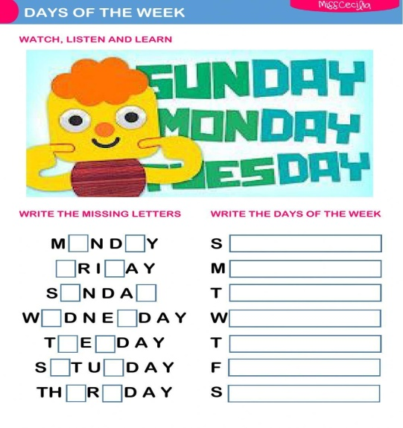  Allow the pupils some time to read the sentences silently and complete the activity.  •Can describe the picture  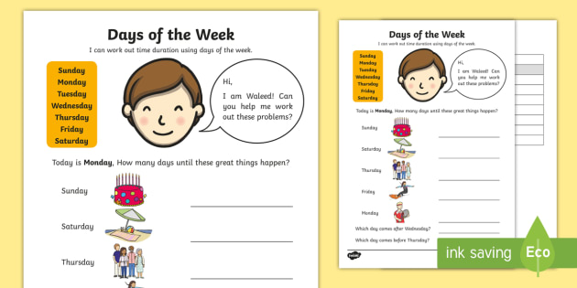  The pupils read the texts silently and answer the questions in their notebooks | Formative assessment  Feedback | Worksheets 1  Worksheets 2
10 minutes | ENDING THE LESSON:  Well what did we do in our lesson?  - Evaluation of the lesson  Give the home task  Sing a Good bye song | Children sing a Good bye song | Feedback | https://www.youtube. com/watch?v= Xcws7UWWDEs

